Tuesday – Saturday, 9 am to 4 pm | HEAVY EQUIPMENT RENTALS  Effective October 2023  Prices are subject to change without notice.
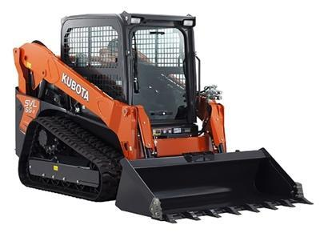  Kubota Compact Track Loader SVL65-2  Attachments for Kubota track loader  - Stump grinder (SSG2524)  - Skid cutters (SC40 series) for clearing grass, weeds, and brush up to 4” diameter.  - Auger for digging holes. |  | ON Peninsula total (tax + delivery) | OFF Peninsula total (tax + delivery)
 | 1 day (8 metered hours max): | $497.26 | $540.50
 | 2 days (16 metered hours max): | $821.56 | $864.80
 | 3 days (24 metered hours max): | $1,145.86 | $1,189.10
 | 4 days (32 metered hours max): | $1,362.06 | $1,405.30
 | 5 days (40 metered hours max): | $1,686.36 | $1,729.60
 | 6 days (48 metered hours max): | $2,010.66 | $2,053.90
 | 7 days (56 metered hours max): | $2,226.86 | $2,270.10
 | Attachments for the Kubota Compact Track Loader cost an additional one-time $108.10 fee (includes tax).
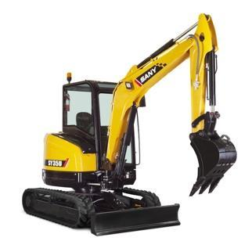  Sany Mini Excavator SY35U | 1 day (8 metered hours max): | $497.26 | $540.50
 | 2 days (16 metered hours max): | $821.56 | $864.80
 | 3 days (24 metered hours max): | $1,145.86 | $1,189.10
 | 4 days (32 metered hours max): | $1,362.06 | $1,405.30
 | 5 days (40 metered hours max): | $1,686.36 | $1,729.60
 | 6 days (48 metered hours max): | $2,010.66 | $2,053.90
 | 7 days (56 metered hours max): | $2,226.86 | $2,270.10
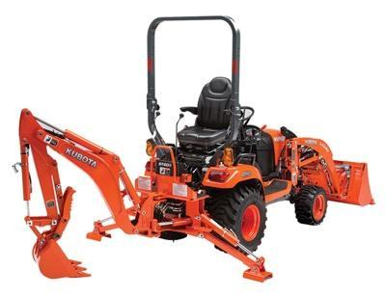  Kubota Backhoe/Loader BX23S | 1 day (8 metered hours max): | $389.16 | $432.40
 | 2 days (16 metered hours max): | $713.46 | $756.70
 | 3 days (24 metered hours max): | $1,037.76 | $1,081.00
 | 4 days (32 metered hours max): | $1,253.96 | $1,297.20
 | 5 days (40 metered hours max): | $1,578.26 | $1,621.50
 | 6 days (48 metered hours max): | $1,902.56 | $1,945.80
 | 7 days (56 metered hours max): | $2,118.76 | $2,162.00

All rentals are subject to a $100 reservation fee, which will be applied to the first day’s rental costs, or refunded if the reservation is canceled more than 72 hours in advance. If a reservation is canceled less than 72 hours in advance, the fee will not be refunded.
Operator/renter is required to be present during the time of drop off and pick up. Inspection/signature is required at the time of drop off and pick up by both the operator and the PLS employee responsible for the delivery. If the operator/renter cannot be present during the time of pick-up, operator/renter waives their right to dispute any non-compliances listed on the delivery form.
Machine will come with a full tank of fuel (diesel). Machine MUST come back fully fueled. Operator/renter will be charged $9.99 per gallon of fuel if it’s not filled at the time the equipment is picked up. Operator/renter is responsible for additional fuel during the rental period. An empty diesel fuel can will be provided. This is for DIESEL ONLY and must be returned with equipment. Diesel fuel can does not need to return full. If the fuel can is not returned, operator/renter will be charged $55.
Operator/renter will not be refunded for hours not used; the machine is charged per day. 1 day = 8 metered hours. Extra Meter Hours: $80. If the machine has more than the maximum meter hours allotted, renter will be charged $80 per extra hour used.
Damage fees may apply. If the machine has any new damage during the rental time, renter will be charged for a full repair. A credit card number is required for all heavy equipment rentals.

